EXERCISE:1

AIM:

CODE:

x<-c(1,2,3,4)

print(x)

z=c(1,4,6,7)

y=c(3,4,5,7,9,1)

print(length(z))

print(length(y))

print(x+z)

print(ls())

rm(x,y)

print(ls())

rm(list=ls())

print(ls())

x=matrix(data=c(1,2,3,4), nrow=2, ncol=2)

print(x)

x=matrix(c(1,2,3,4) ,2,2)

print(x)

y=matrix(c(1,2,3,4) ,2,2,byrow=TRUE)

print(y)

print(sqrt(y))

print(y^2)

x=rnorm(50)

y=x+rnorm(50,mean=50,sd=.1)

print(cor(x,y))

set.seed(1303)

print(rnorm(50))

set.seed(3)

y=rnorm(100)

print(mean(y))

print(var(y))

print(sqrt(var(y)))

print(sd(y))

OUTPUT:

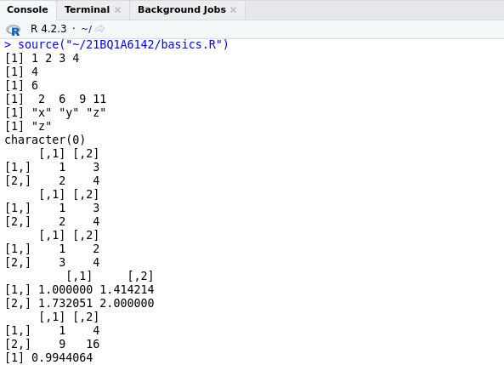

OUTPUT:

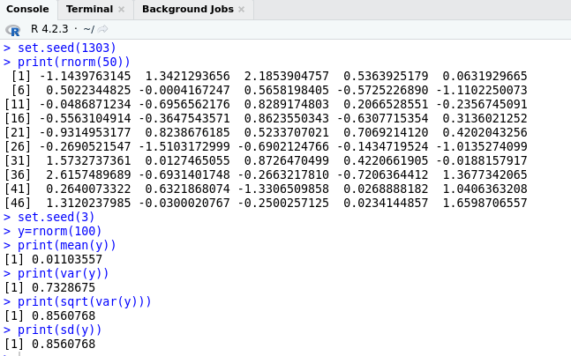

GRAPHICS:

CODE:

x=rnorm(100)

y=rnorm(100)

plot(x,y)

OUTPUT:

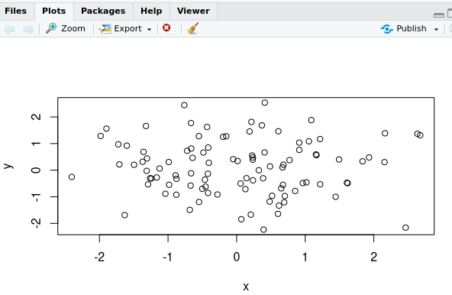

CODE:

plot(x,y,xlab="this is the x-axis",ylab="this is the y-axis", main="Plot of X vs Y")

OUTPUT:

